**[Has Obama Broken the Israel Lobby?](http://r20.rs6.net/tn.jsp?e=001QkZCasECrHND4odtp80XCTzQeSxcYGC3gXOAiCX9Qe3pBHX4oX-c29MXguZluvQ7VXsWAKUaTg0caIzS0tYFnRjwzTNDtMr6M11pTHZIqZfqfTPaeB4_DDD4V-cr-1dic3EHEerwBsJji9L53vMp3f_5HOMn7IcIF4gC0U577uk2EVnswX-uqfCIkFH4XoFcbCNAs5eFiJU=" \t "_blank)**

# [What the Hagel victory means](http://walt.foreignpolicy.com/posts/2013/02/27/has_obama_defeated_the_israel_lobby)

## Posted By [Stephen M. Walt](http://www.foreignpolicy.com/author/Stephen%20M.%20Walt) http://www.foreignpolicy.com/images/091022_meta_block.gif Wednesday, February 27, 2013 - 8:32 AM

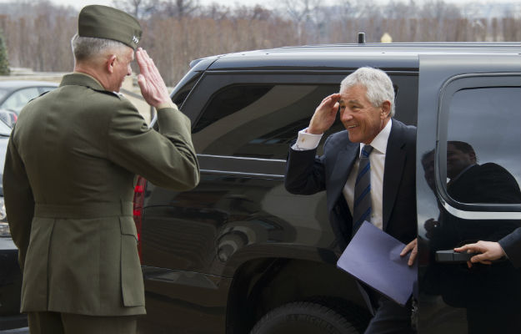

I suspect a lot of people would like to believe Chuck Hagel's confirmation as secretary of defense shows that Obama has broken the back of the Israel lobby and will now move U.S. Middle East policy in a direction that would be better for us, better for Israel, better for the Palestinians, and maybe even better for the entire region.

Don't count on it.

It is of course a very good thing that the Senate confirmed Hagel. He had excellent credentials for the job, had done nothing to disqualify himself, and to have been denied the post on the basis of the lobby's slander would have been truly disheartening. And there's no question that the antics of

* the Emergency Committee for Israel (note: *for Israel,*not the U.S.),
* the *Washington Free Beacon*,
* Elliot Abrams,
* Ted Cruz,
* Jennifer Rubin, et al.

ultimately did more harm to themselves than to Hagel. They revealed both their preference for innuendo over facts and their belief that support for Israel matters more than any other aspect of U.S. defense policy. As I've noted before, their behavior merely confirmed what some of us have been saying for a very long time, and they did so center-stage with the spotlight on. Very gratifying indeed.

But it would be a huge mistake to conclude that the lobby's clout has been broken and that Obama will now be free to chart a new course. For starters, the behavior of several senators on the Senate Armed Services Committee shows that they are still mightily beholden to groups like AIPAC and extremist Christian Zionists, not to mention some unrepentant neoconservatives. Chuck Hagel was about as bulletproof a candidate as one could ask for (decorated war hero, defense and intelligence expert, successful businessman, respected ex-senator, etc.) and that didn't stop these zealots from unloading the SIOP against him. The fact that they ultimately failed is important, but so is the fact that they could even make an issue of it. The lobby failed to stop Ronald Reagan from selling AWACs to Saudi Arabia in 1981, but they made him work really, really hard to get the deal through and he never took them on again.

One should also remember that Obama has basically been caving in to the lobby ever since 2009, which tells you something about its clout. It's true that he doesn't have to run for reelection again. But most of those Congressmen do, and they aren't going to back him up if he tries to play hardball with Netanyahu. The annual aid package to Israel will be approved like clockwork, which means Obama won't have many levers to use if he needs to push both sides toward a peace deal.

And that's why I [**previously argued**](http://walt.foreignpolicy.com/posts/2012/12/28/looking_back_and_looking_forward)that you aren't going to see a big Middle East peace push during the second term. Sure, Obama might let John Kerry see what he can accomplish. But Netanyahu will just stiff him, and Obama won't do anything about it. The Palestinians are still divided and too weak to negotiate a fair deal, and conditions throughout the region are hardly propitious for compromise. If Obama is looking for a legacy, in short, the Middle East is not the place to find it. And I suspect he knows that.

Which is not to say that there isn't good news here. The pro-peace, pro-two state lobby J Street's support for Hagel was vindicated, and that's likely to win them greater access going forward. (I mean, who *really*wants to be in the company of the smear artists who went after Hagel?) Hagel's confirmation and the lobby's defeat diminishes the push for war with Iran -- which is a good thing -- and might encourage the administration to formulate a negotiating strategy toward Tehran that has some prospect of success (as opposed to the dead-on-arrival offers we've been making so far). And it certainly doesn't hurt for politicians in Washington to be reminded that the lobby doesn't win every time.

But the bottom line is that no powerful interest group disappears after a single defeat. Even when a lobby doesn't get its way, it can gain a partial victory by making the winning side pay a price, and by reminding everyone that it can still make trouble. And that was the lobby's real strategy here. They probably knew that Hagel was likely to be confirmed, for the simple reason that he was a well-qualifed candidate whose patriotism was beyond question. Their aim instead was to deter future administration from nominating people who weren't lobby-certified, *and*to discourage ambitious young foreign policy professionals from doing or saying anything that might put the lobby's crosshairs on them.

In short, so long as opportunistic rabble-rousers like Ted Cruz believe that pandering to the lobby is the smart political play, Capitol Hill will remain supine, the executive branch will be constrained, and U.S. Middle East policy will be about as successful as its been for the last couple of decades.